ASSIGNMENT 4

AIM:
To design a CMOS inverter and
a. Calculate rise and fall time with and without load capacitor.
b. Plot VTC for DC input and calculate noise margin.
CIRCUIT:
CMOS inverter has been designed as follows -
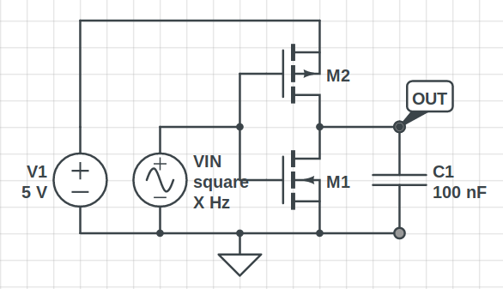
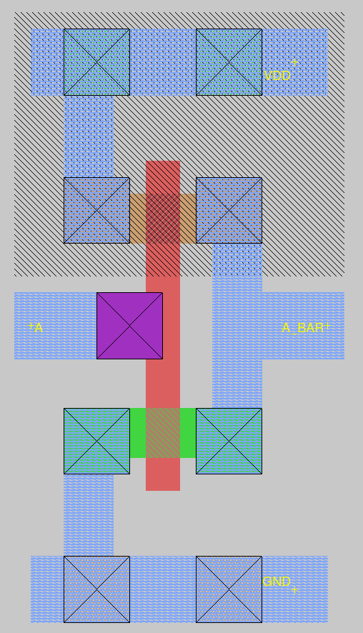

MAGIC LAYOUT:

OBSERVATIONS:
1. Vout and Vin wrt time
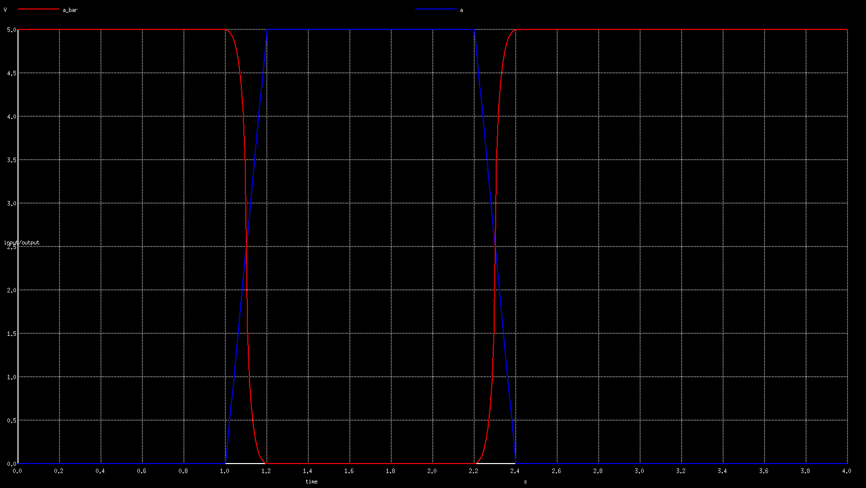

We find that with CL = 0.1u
Fall Time, Tf = 6.207914 x 10⁻² s
Rise Time, Tr = 6.243712 x 10⁻² s
Propagation Delay, TPHL = 4.570014 x 10⁻³ s
Propagation Delay, TPLH = 4.727911 x 10⁻³ s
Propagation Delay, TP = (TPHL + TPLH)/2 = 4.648963 x 10⁻³ s

We find that without CL
Fall Time, Tf = 6.199314 x 10⁻² s
Rise Time, Tr = 6.195805 x 10⁻² s
Propagation Delay, TPHL = 4.918616 x 10⁻⁷ s
Propagation Delay, TPLH = 4.719901 x 10⁻⁷ s
Propagation Delay, TP = (TPHL + TPLH)/2 = 4.819259 x 10⁻³ s

2. VTC
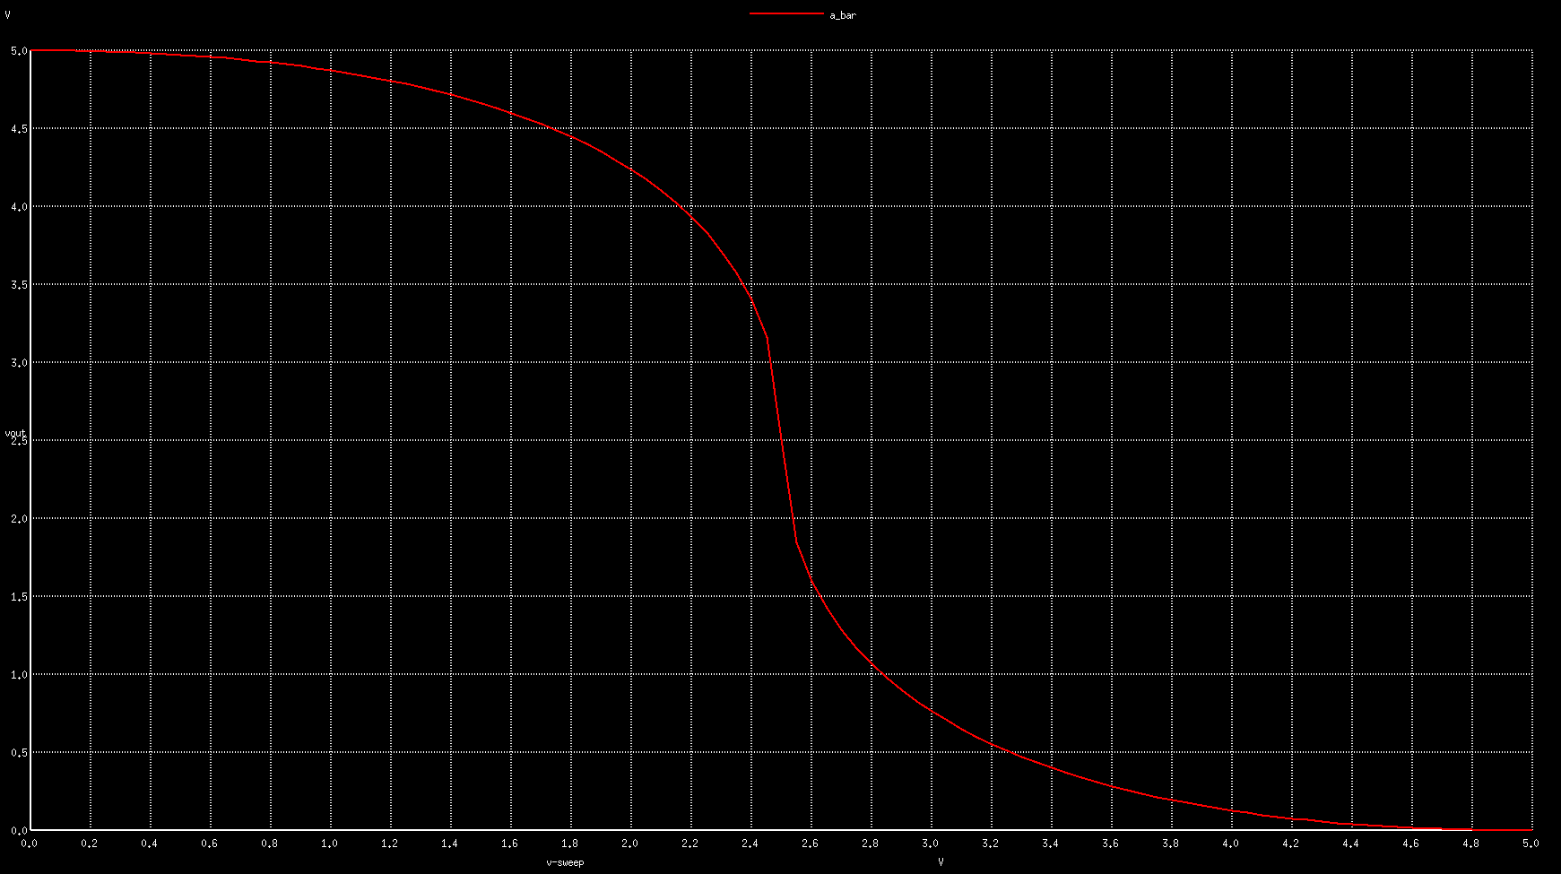

Since NGSPICE derivative function wasn’t working it was difficult to find out the noise margin.

CONCLUSION:
Addition of capacitive load increased the propagation delay by a large margin while the fall time was hardly affected.

